Graduate outcomes (LEO): subject by provider:
How to read boxplots in this publication

2020/21 tax year data

- How to read boxplots (Earnings and employment outcomes across providers by subject)
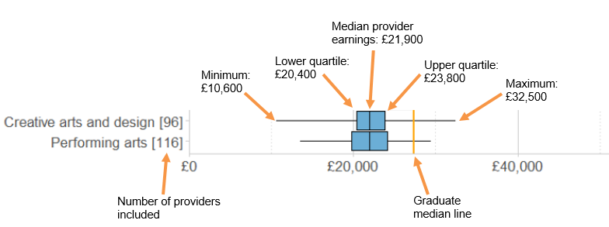
The median earnings is calculated by ranking all providers’ median annualised earnings in each subject and taking the value at which half of providers fall above and half fall below. In particular, the median displayed here is not the same as the median for all graduates.
The lower quartile earnings is calculated by ranking all providers’ median annualised earnings and taking the value at which three quarters of providers fall above and one quarter fall below.
The upper quartile earnings is calculated by ranking all providers’ annualised earnings and taking the value at which one quarter of providers fall above and three quarters fall below.
The graduate median line shows the graduate earnings median for the tax year. This was published in LEO Graduate and Postgraduate Outcomes: 2020-21.

- How to read boxplots for regional analysis (Earnings and employment outcomes by current region)
The boxplots for regional analysis are as above but with the following differences:

The median earnings for each region is calculated by ranking all institutions’ by the median annualised earnings of their graduates in each region and taking the value at which half of providers fall above and half fall below.
The lower quartile earnings is calculated by ranking all institutions’ median annualised earnings in each region and taking the value at which three quarters of providers fall above and one quarter fall below.
The upper quartile earnings is calculated by ranking all institutions’ median annualised earnings in each region and taking the value at which one quarter of providers fall above and three quarters fall below.

