LEO Graduate outcomes provider level data:

How to read boxplots in this publication

2021/22 tax year data

1. **How to read boxplots (Earnings and employment outcomes across providers by subject)**

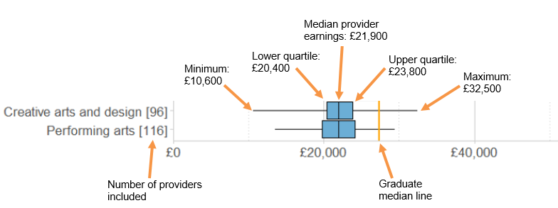

A median is calculated by ranking all values and taking the one in the middle, such that half the values fall below and half the values fall above it. The lower quartile is the value above which three quarter of the values fall, and the upper quartile is the value above which one quarter of the values fall.

For the earnings by subject boxplots, we (1) calculated median earnings for a particular subject area *within each provider* to generate median earnings by subject and provider, and (2) calculated median earnings within that subject area across all providers using the median earnings by subject values calculated in (1). Note that the median displayed for a particular subject area here is not the same as the median for all graduates who studied that subject.

The graduate median line shows the graduate earnings median for the tax year. This was published in [LEO Graduate and Postgraduate outcomes 2021-22](https://explore-education-statistics.service.gov.uk/find-statistics/leo-graduate-and-postgraduate-outcomes/2021-22).

1. **How to read boxplots for regional analysis (Earnings by provider region)**

**The boxplots for regional analysis are as above but with the following differences:**

The median earnings for each region is calculated by ranking all institutions’ by the median annualised earnings of their graduates **in each region** and taking the value at which half of providers fall above and half fall below.

The lower quartile earnings is calculated by ranking all institutions’ median annualised earnings **in each region** and taking the value at which three quarters of providers fall above and one quarter fall below.

The upper quartile earnings is calculated by ranking all institutions’ median annualised earnings **in each region** and taking the value at which one quarter of providers fall above and three quarters fall below.