have added

**Progression to Higher Education by age - a cohort measure**

**Experimental Statistics**

**November 2020**

**Contents**

Introduction 3

Method 4

Matching Process 4

Overall Estimates 4

Comparison to HEIP Measure 5

Differences in methodology 5

Comparison of Progression Rates 6

Progression by Gender and Region 7

Gender 7

Region 8

Progression by Characteristics – Example Analysis 9

Free School Meal Status 9

Ethnic Group 10

Other personal characteristics 10

# Introduction

The Higher Education Initial Participation (HEIP) measure[1] was introduced to build a timely estimate of participation in Higher Education by age.

The main limitations of the HEIP methodology are the difficulty in disaggregating progression rates by geography, ethnicity and other personal characteristics due to the lack of reliable and comparable population estimates for detailed groupings.

Another important limitation is its susceptibility to overstate participation by age 30 if there is growth in the number of higher education entrants in younger age groups.

The HEIP measure is an estimate of the actual entry rate in the current year of people who had not previously entered higher education between ages 17 to 30. For each age from 17 to 30, the initial participation rate is calculated as the fraction of the academic year population that are initial entrants. These rates are added to create the total HEIP measure. It is not a measure of participation by particular entry cohorts.

When there is steady growth in entry rates for younger age groups (as has been observed over many years for English 18 year-olds), the HEIP method of summing current participation rates will show a higher participation rate than the participation rate for a particular entry cohort. For example, today’s 30 year-olds, will have had a lower initial participation rate when they were aged 18 compared to today’s 18 year-olds.

This document presents an alternative measure of entry to higher education by age, which is described as a cohort measure of progression. This makes use of matched data from the National Pupil Database (NPD), which continues to expand each year and now allows us to track individuals up to age 32 for the earliest entry cohort of 15 year olds at Key Stage 4 in 2001/02.

The cohort measure builds on the existing methodology used in the DfE publication [Widening Participation in Higher Education](https://www.gov.uk/government/collections/widening-participation-in-higher-education), but extends the publication further to look at progression to HE between the ages of 20 and 30.

The cohort measure benefits from having a reliable estimate of the population across a wide range of personal characteristics and geographic breakdowns that is less susceptible to inward and regional migration in the population than HEIP. This enables analysis of progression rates by ethnic group, free school meal status, region and other personal characteristics.

There remain limitations in this approach, as the cohort measure is less timely than the HEIP in providing an estimate of participation by age 30. This is because the cohort method measures progression of a historical cohort rather the estimated progression of the current cohort under the HEIP measure. The cohort measure is therefore less able to account for recent changes in HE entry by mature students.

This document sets out how the new cohort measure is created, how it compares to the HEIP measure and also provides some examples of the type of new analysis that can be done using the cohort approach.

A supporting Excel document can be found attached to the release containing data used in charts throughout.

# Method

The cohort used is pupils at Key Stage 4 in English schools who were aged 15 in the period 2003/04 to 2016/17.

We track their progression to UK Higher Education between the ages of 17 and 30 up to HE entry in 2018/19.

The measure is calculated using matched data. This matches the National Pupil Database to the Education and Skills Funding Agency (ESFA) Individualised Learner Record and the Higher Education Statistics Agency (HESA) Student Record and Alternative Provider Student Record. This allows pupils to be tracked from English schools at age 15 to Higher Education by age 30. The measures cover HE courses at UK Higher Education Institutions, Alternative Providers and English Further Education Colleges.

The data includes pupils who attended state-funded and independent schools at age 15, however detailed personal characteristics are only available for those who attended state-funded schools.

It must be noted, due to the matching procedures deployed, all figures in this publication should be treated as estimates.

Note that the figures in this document will differ slightly from those in the [Widening Participation in Higher Education](https://www.gov.uk/government/collections/widening-participation-in-higher-education) publication (which this measure is based upon). This cohort measure refers to a wider population of students as it additionally includes 15 years old who attended independent schools.

# Matching Process

The National Pupil Database (NPD) contains administrative data on all pupils in schools in England, collected by the Department for Education. Key Stage 4 (KS4) data and Pupil Level Annual School Census (PLASC) records were matched to the Higher Education Statistics Agency’s (HESA) Student Record and Alternative Provider Student Record, and the Education and Skills Funding Agency (ESFA) Individualised Learner Record (ILR).

The matching process allows for school pupils to be tracked through to Higher Education. The match achieved is called a “fuzzy match” where we rely on names, postcodes, dates of birth, etc and there is some potential for minor errors in the matching process. For this reason, the figures are deemed estimates due to the reliability of the matching procedure used.

The match quality is high, although match rates for independent schools are known to be slightly lower than for state-funded schools and so HE progression rates for independent schools may be slightly more likely to be underestimated.

# Overall Estimates

The chart below shows the cumulative HE progression rate by age for each Key Stage 4 cohort for HE entry up to 2018/19. This shows a clear trend of increasing progression rates by age and over time for each age group.

The peak progression rate is currently 48.3% for students who were at Key Stage 4 in 2011/12 and progressed to HE by age 22 in 2018/19.

We would expect this rate to continue to increase over time as students get older, although the rate of increase diminishes with age.

We have seen positive increases in the cumulative progression rate for all ages when looking at 2018/19 entry, except for progression by age 19, which fell slightly from 43.7% to 43.2% in the latest year.

**Progression to Higher Education by age and year aged 15**

Pupils in English schools at age 15 in 2003/04 to 2016/17

Higher Education Entry between 2005/06 and 2018/19

UK Higher Education Providers and English Further Education Colleges

Heat map showing progression to higher education by age and year aged 15. The chart shows progression increases with age and over time. The peak progression rate is currently 48.3% for students who progressed to HE by age 22 in 2018/19.

# Comparison to HEIP Measure

### Differences in methodology

It is not possible to make an exact comparison between the HEIP measure and the cohort measure due to differences in methodology and the population used.

The HEIP measure uses a methodology that attempts to estimate the likelihood of a young person participating in HE by age 30, based on current participation rates.

Under the cohort measure, the latest data for entry by age 30 relates to students who were in Key Stage 4 in 2003/04 and so the impact of recent increases in entry rate for younger students is not taken into account.

The table below summarises the key differences between the components of the two measures.

|  |  |  |
| --- | --- | --- |
| **Component** | **Cohort Measure** | **HEIP Measure** |
| Population | Pupils in English Schools at age 15 | English Population Estimates by age and not necessarily schooled in England |
| HE Entrants | All domiciles but present in English schools at age 15 | English domiciled prior to HE entry and not necessarily schooled in England |
| HE Participation | At least 2 weeks | At least 6 months |

The population used for the latest year’s HEIP measure relates to the whole population of England by age for 2018/19, and therefore includes net migration and students outside the mainstream (for example home schooled and forces children) who are not in the cohort measure.

Although the cohort measure includes all HE entrants from all domiciles, given it is restricted to pupils who were in English schools at 15, it is not affected by the impact of immigration and migration between the countries of the UK in the way the HEIP measure is – students who move to England prior to starting their HE course are counted as English domiciled in the HEIP measure.

The cohort measure counts HE entry where the student has been in attendance for at least 2 weeks in order to be consistent with the methodology in the [Widening Participation in Higher Education](https://www.gov.uk/government/collections/widening-participation-in-higher-education) publication on which it is based. Under the HEIP methodology students have to attend HE provision for at least 6 months to be included.

Despite these differences in methodology, the measures have strong similarities and the comparison between the two can help to understand the benefits and disadvantages of each.

### Comparison of Progression Rates

We have seen consistent increases in HE progression rates over the past few years and the latest HEIP estimates that the participation rate for 17 to 30 years old reached a new high of 51.9% in 2018/19. Under the cohort measure, the recent increases in progression rates for younger students will not feed through into a 17-30 measure for several years, and the peak progression rate is currently 48.3% for students who progressed to HE by age 22 in 2018/19.

In order to attempt to compare the cohort measure and the HEIP measure more directly, we can create initial participation rates from the cohort measure on a similar basis to the HEIP measure, looking at the change in entry rates by age between 2017/18 and 2018/19.

The table below shows how the initial entry rates at each age differ under the two measures.

**Comparison of initial entry rates by measure**

|  |  |  |  |  |  |  |  |  |  |  |  |  |  |  |
| --- | --- | --- | --- | --- | --- | --- | --- | --- | --- | --- | --- | --- | --- | --- |
| **Age in 2018/19** | 17 | 18 | 19 | 20 | 21 | 22 | 23 | 24 | 25 | 26 | 27 | 28 | 29 | 30 |
| **HEIP Measure** | 0.2% | 29.4% | 11.6% | 3.3% | 1.6% | 1.1% | 0.9% | 0.8% | 0.7% | 0.6% | 0.5% | 0.5% | 0.5% | 0.4% |
| **Cohort Measure** | 0.2% | 31.1% | 12.2% | 3.3% | 1.6% | 1.1% | 0.9% | 0.8% | 0.5% | 0.4% | 0.3% | 0.3% | 0.3% | 0.3% |
| **Difference (HEIP – Cohort)** | 0.0% | -1.8% | -0.7% | 0.0% | 0.0% | 0.0% | 0.0% | 0.0% | 0.2% | 0.2% | 0.2% | 0.2% | 0.2% | 0.2% |

Both measures follow a similar profile, however, the cohort approach gives higher estimates for HE entry at age 18 and 19 and lower estimates for entry at age 25 or later.

As discussed above these differences are likely to stem from the different definitions of HE entry as well as differences in the students included in either measure and the population used to calculate entry rates.

The higher rates at younger ages for the cohort measure will reflect the looser definition of participation in HE used and smaller population figures used in the calculation of the rate as these will not include any individuals outside the English school system.

The higher rates at older ages for the HEIP measure are likely to reflect the impact of international migration, as the population of English domiciled students used in the measure is likely to include non-English nationals who were not schooled in England but had lived there long enough to be considered as domiciled in England when they entered higher education.

# Progression by Gender and Region

We are able to produce progression rates under the cohort measure by gender and by region for pupils attending all school types, whilst more detailed personal characteristics are only available for students who attended state-funded schools.

### Gender

Progression rates by age by gender show a similar pattern to the overall trend, with peak progression rates for those who progressed to HE by age 22 in 2018/19.

The progression rate by age 22 in 2018/19 was 53.2% for females, almost 10 percentage points higher than the rate for males (43.7%).

**Progression to Higher Education for Females by age, year aged 15**

Pupils in English schools at age 15 in 2003/04 to 2016/17

Higher Education Entry between 2005/06 and 2018/19

UK Higher Education Providers and English Further Education Colleges

Heat map showing progression to higher education by age and year aged 15 for females. The chart shows progression increases with age and over time. The peak progression rate is currently 53.2% for students who progressed to HE by age 22 in 2018/19.

**Progression to Higher Education for Males by age, year aged 15**

Pupils in English schools at age 15 in 2003/04 to 2016/17

Higher Education Entry between 2005/06 and 2018/19

UK Higher Education Providers and English Further Education Colleges

Heat map showing progression to higher education by age and year aged 15 for males. The chart shows progression increases with age and over time. The peak progression rate is currently 43.7% for students who progressed to HE by age 22 in 2018/19.

### Region

The progression rates in this section relate to the region of the school the pupil attended at age 15.

For most regions, as is the case nationally, the peak progression rate is currently for students progressing to HE by age 22 in 2018/19. The lower progression rates by older ages reflects the fact that progression rates for younger students have increased substantially in the past decade.

The chart below shows how progression rates differ by selected age in 2018/19 and region.

**Progression to Higher Education by age and Region**

Student age in 2018/19

UK Higher Education Providers and English Further Education Colleges

Region of school attended at age 15

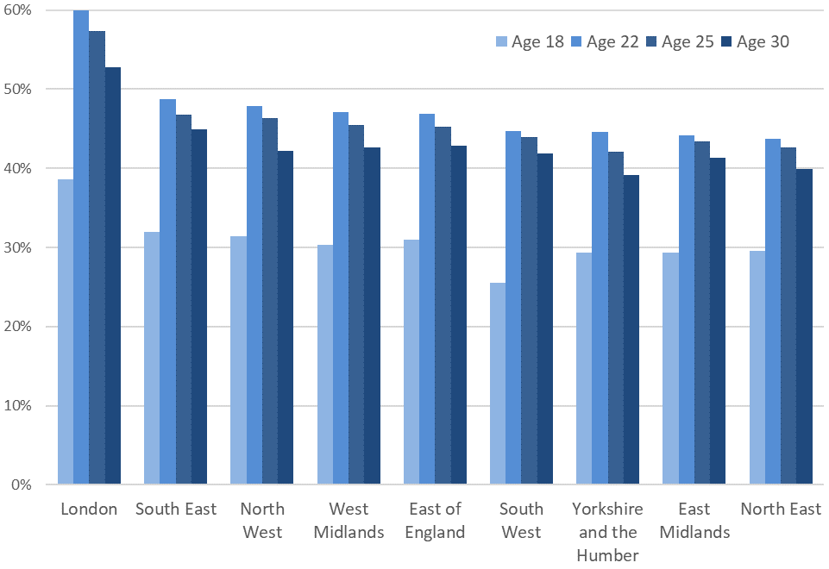

The clear pattern is higher progression rates in London at all ages, with progression rates being much more uniform across the other regions.

The North East and Yorkshire and the Humber tend to see the lowest progression rates regardless of age but we do see some different patterns in progression by age across regions. Most notably, the South West has the lowest progression rate by age 18 of all the region at 26%. However, the rate increases with age more quickly than other regions. The East Midlands also has some of the lowest progression rates for younger students in particular.

# Progression by Characteristics – Example Analysis

This section presents some examples of the type of analysis it is possible to do using the cohort measure. Detailed personal characteristic information is only available for pupils who attended state-funded schools at age 15. Pupils who attended independent schools (who were included in the earlier analysis) are not included here.

We focus on progression to HE by age for students who were age 15 in 2003/04 in order to track HE entry up to age 30.

*Note that variations in progression to HE by student characteristics can largely be explained by prior attainment. Prior attainment is not accounted for by the measures presented here.*

### Free School Meal Status

Progression rates for Free School Meal pupils lag well behind other pupils. Pupils eligible for FSM are more likely to enter HE at older ages than other students, however the large gap remains. Just 9.5% of FSM pupils had progressed to HE by age 18 compared to 23.5% of other pupils. By age 30, the rate for FSM pupils had almost trebled to 25.7% but this remained well below the rate of 44.1% for other pupils.

**Progression to Higher Education by age and Free School Meal status**

Pupils aged 15 in 2003/04 at state-funded schools

Higher Education Entry between 2005/06 and 2018/19

UK Higher Education Providers and English Further Education Colleges

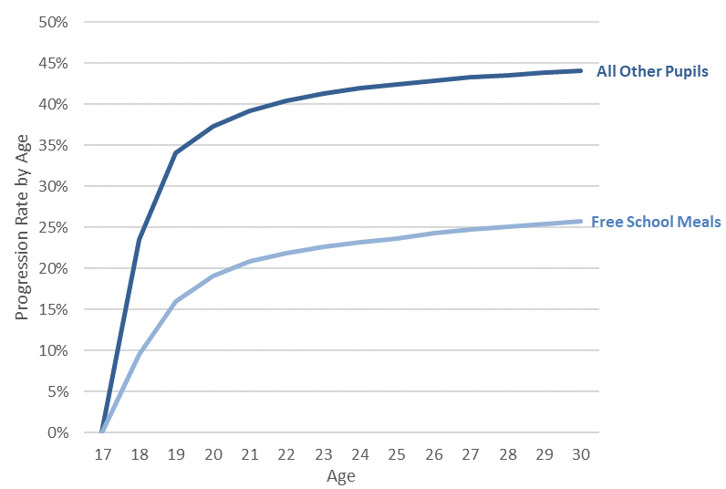

### Ethnic Group

The differences in progression to HE by age are starker when looking at entry by ethnic group.

Chinese and Indian pupils are the most likely to progress to HE and also the most likely to progress at younger ages.

Black pupils tend to enter HE later than other pupils on average. Of the main ethnic groups, Black Caribbean pupils have the lowest progression rates by age 19, just behind White British pupils.

However, by the age of 30, the progression rate for White British pupils lags well behind other pupils at 38.7% compared to 48.5% for Black Caribbean, 53.4% for Pakistani, 53.7% for Bangladeshi, 69.2% for Black African, 74.5% for Indian and 82.1% for Chinese pupils.

**Progression to Higher Education by age and selected Ethnic Groups**

Pupils aged 15 in 2003/04 at state-funded schools

Higher Education Entry between 2005/06 and 2018/19

UK Higher Education Providers and English Further Education Colleges

Chart showing how progression to higher education builds up by age up to 30 for pupils who were 15 in 2003/04 by ethnic group. Chinese and Indian pupils are the most likely to progress to higher education and also the most likely to progress at younger ages.
Black pupils tend to enter higher education later than other pupils on average.

### Other personal characteristics

This document provides some examples of analysis that can be carried out but there are options for more detailed analysis in future covering progress to HE by age and Special Education Needs, First Language, POLAR disadvantage, Children in Need and Looked After Children.

More examples of the type of analysis that can be carried out can be found in the DfE publication [Widening Participation in Higher Education](https://www.gov.uk/government/collections/widening-participation-in-higher-education)



© Crown copyright 2020

You may re-use this document/publication (not including logos) free of charge in any format or medium, under the terms of the Open Government Licence v2.0. Where we have identified any third-party copyright information you will need to obtain permission from the copyright holders concerned.

To view this licence:

visit [www.nationalarchives.gov.uk/doc/open-government-licence/version/2](https://educationgovuk-my.sharepoint.com/personal/cameron_race_education_gov_uk/Documents/www.nationalarchives.gov.uk/doc/open-government-licence/version/2)

email [psi@nationalarchives.gov.uk](https://educationgovuk-my.sharepoint.com/personal/cameron_race_education_gov_uk/Documents/psi@nationalarchives.gov.uk)

About this publication:

enquiries [www.education.gov.uk/contactus](https://educationgovuk-my.sharepoint.com/personal/cameron_race_education_gov_uk/Documents/www.education.gov.uk/contactus)

download [www.explore-education-statistics.service.gov.uk](http://www.explore-education-statistics.service.gov.uk)



Follow us on Twitter: [@educationgovuk](http://www.twitter.com/educationgovuk)



Like us on Facebook: [facebook.com/educationgovuk](http://www.facebook.com/educationgovuk)

1. Formerly the Higher Education Initial Participation Rate (HEIPR).